SeaLife Tech advice

For Authorized SeaLife Service Centers

**Date:** September 21, 2009

**Subject:** Shutter Button Sticks at depth.

**Applies to**: DC800 and DC1000

**Symptoms**: The underwater housing shutter button sticks at depth below 40/50 meters.

**Cause:** As of March 2009, we have modified all DC800 and DC1000 housings which prevent the shutter button from sticking at depth. We have learned that it is still possible in some cases that the shutter button assembly sticks at depth.

When the shutter button is pushed down all the way [to the bottom of its working range], the shutter assembly is angled slightly away from its normal vertical position. The combination of this abnormal shutter position and water pressure greater the 40 meters may cause the shutter button to stick.

**Scope:** This problem MAY OCCUR with any DC800 and DC1000 cameras, but is more common with housings having a serial # less than 710360.

**Solution:** If the serial # is less than 710360, please return the housing to SeaLife USA for repairs. SeaLife will make all necessary modifications/repairs and promptly return the cleaned and tested housing.

If the serial # is greater than 710360, authorized service centers can make the following repair to correct the problem.

1. Use a small precision screwdriver to unscrew the shutter button hinge pin and remove the shutter button cover.

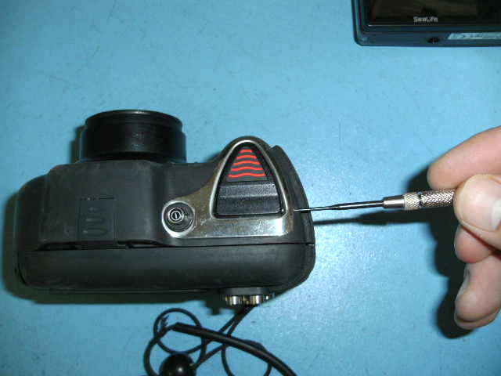

1. Remove the two screws which secure the shutter button trim plate.

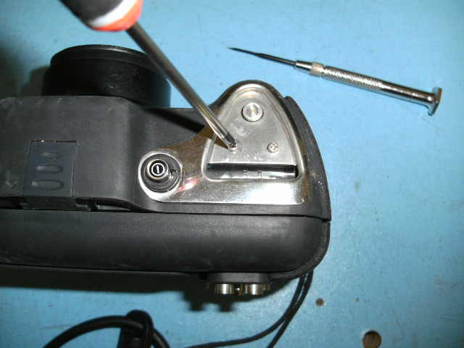

1. Use pressured air to clean away and sand and debris from the exposed shutter assembly and parts.

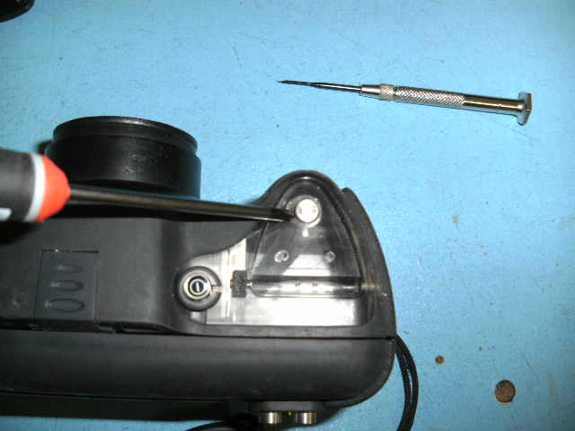

1. Add the .025” shim around the metal shutter button as shown below

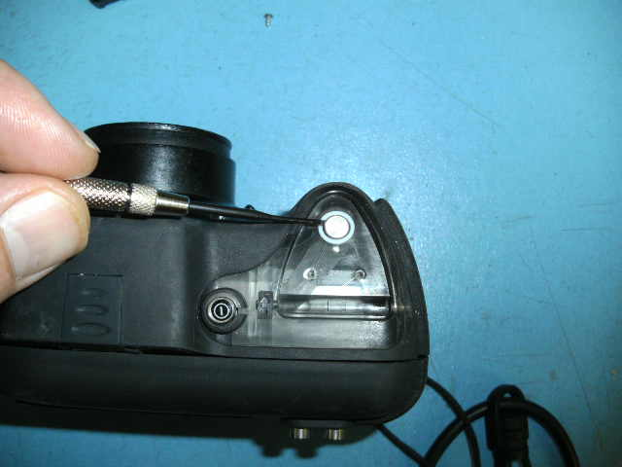

1. Reassemble shutter button trim plate and button cover.

**Warranty:** Yes

**Distribution:** For release to authorized SeaLife Service Centers.

For assistance, please contact:

Karl Schuster, SeaLife Service Dept. ([karl@sealife-cameras.com](mailto:karl@sealife-cameras.com))

Pioneer Research, SeaLife Service Center, 97 Foster Road, Moorestown, NJ 08057

(856) 866-9191 [www.sealife-cameras.com](http://www.sealife-cameras.com/)